Title: **Sealing and Unsealing Circuit** Job: 7

Course: Introduction to Automation Unit: Introduction of PLC CLO: 1, 4

Name ____________________________ Station _______ Date ______________

**Objectives**

1. Student shall reinforce the purpose for a sealing control circuit.
2. Student shall solidify the knowledge for an “OR” circuit.
3. Student shall discover the use of registers as both outputs and inputs.

**Assessment**

Students shall demonstrate a comprehension of the objectives listed above by scoring a minimum of 75% on this shop job. Grading shall be based on the Manual Motor Controls rubric.

**Instructions**

Program the ladder logic shown below. The input I:0/5 is the upper normally open pushbutton (PB2) and the output O:0/0 is the green pilot light. Note that the output register is also being used as an input. One of the many benefits of a PLC is the fact that one piece of data, in this case an output register, can be used in many different locations (i.e. rungs) in multiple forms (inputs, outputs, etc.). This diverges from manual motor controls where if an input only exists once in the real world, it could only be drawn once in a wiring schematic. As just stated, this principle does not apply to PLCs. Also note that rung numbering starts at zero (0000) and sub-rungs, where input O:0/0 resides, is not numbered. This also is different from manual motor control schematics. Verify and download the program.

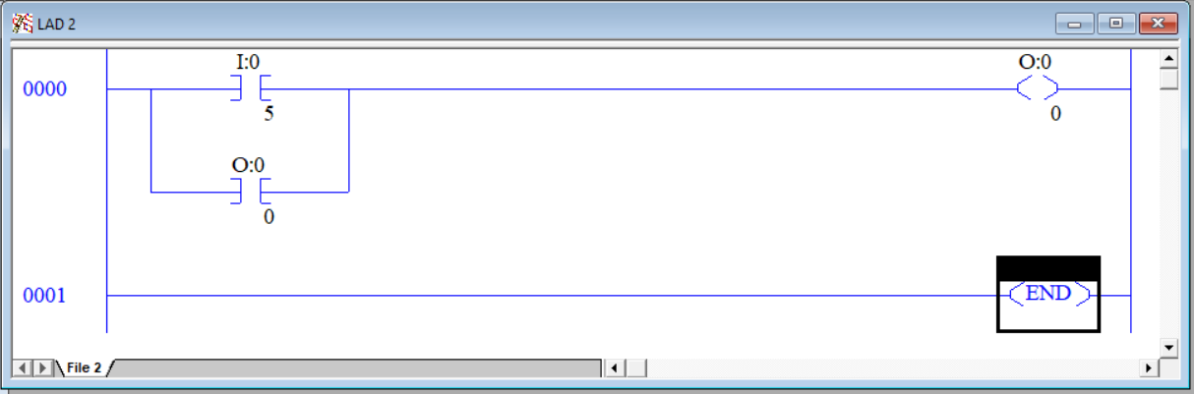

1. After downloading the program but before pressing PB2, complete row *Step 1* in the following truth table.

|  |  |  |  |  |
| --- | --- | --- | --- | --- |
| Step | PB2 | I/5 | O/0 | Green Light |
| 1 | 0 |  |  |  |
| 2 | 1 |  |  |  |
| 3 | 0 |  |  |  |

1. Press and hold PB2, complete row Step 2 in the above truth table.
2. Release PB2 and complete row Step 3 in the above truth table.
3. Explain why the output stays energized and the pilot light stays lit even though the pushbutton is no longer depressed.

__________________________________________________________________

1. This circuit has an inherent problem. What is the problem?

__________________________________________________________________

1. There is a way to improve this circuit to be able to de-energize the output and pilot light. How can this be done? Draw your solution below.

|  |  |  |  |  |  |  |  |  |
| --- | --- | --- | --- | --- | --- | --- | --- | --- |
|  |  |  |  |  |  |  |  |  |
|  |  |  |  |  |  |  |  |  |
|  |  |  |  |  |  |  |  |  |
|  |  |  |  |  |  |  |  |  |
|  |  |  |  |  |  |  |  |  |
|  |  |  |  |  |  |  |  |  |
|  |  |  |  |  |  |  |  |  |

1. Have the instructor review the revised program. Instructor Initials _________
2. After discussing the design and gaining approval, download and test the new program.

**Instructions**

Program the ladder logic shown below.

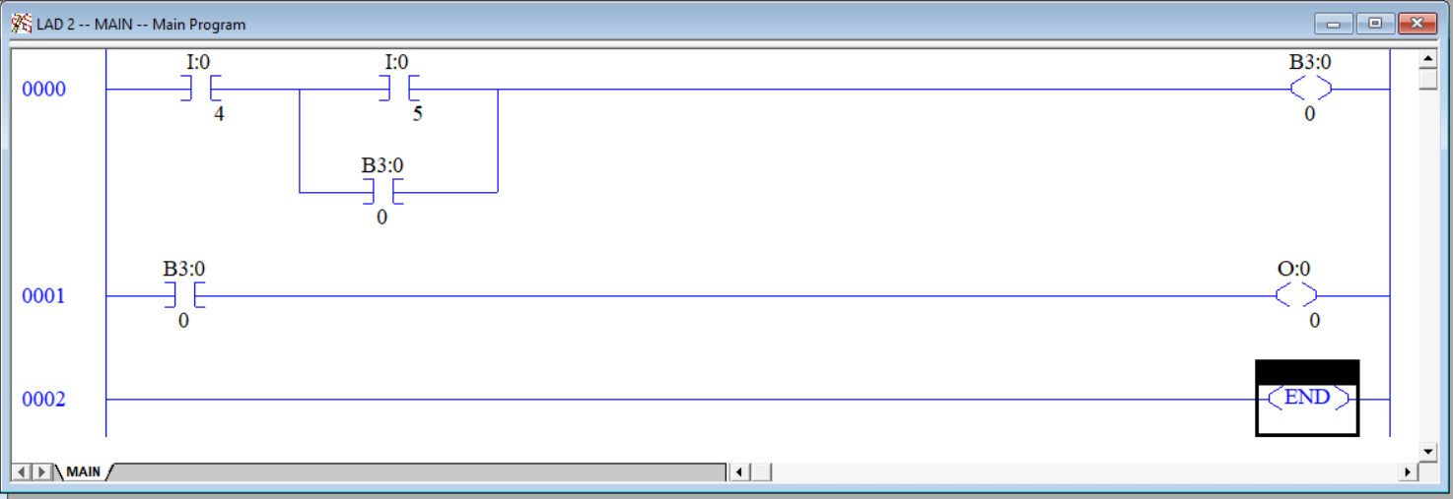

The input I:0/4 is the normally closed pushbutton (PB1) I:0/5 is the upper normally open pushbutton (PB2) and the output O:0/0 is the green pilot light. Notice that I:0/4 appears as a “normally open” set of contacts even though the actual pushbutton is wired “normally closed”. It is important to think of the normally open contact symbol in the PLC, actually termed *examine if closed* or *XIC*, as “test for a 1”. In the case of PB1, if I/4 input is a “1” (has 24VDC), it is permissible to energize the output. If the input is a “0” (has 0VDC), the output should not be energized. This is why an XIC instruction is used for PB1 in this circuit. B3:0/0 is an internal bit that only resides in memory. It is not tied to an input or an output (unless done so within the ladder logic). Another benefit of a PLC is the fact that it contains lots of memory that can be used to hold information other than that of an input or output. Note that 0001 is required for the operator to actually see any change. The state of B3:0/0 would not be known otherwise. Verify and download the program.

While watching RSLogix online perform the following tasks.

1. Press PB1 and note the behavior. _______________
2. Press PB2 and note the behavior. _______________
3. Press PB1 again and note the behavior. _______________

In the space below, design the addition of an ESTOP to this circuit.

|  |  |  |  |  |  |  |  |  |  |  |  |  |  |  |  |  |
| --- | --- | --- | --- | --- | --- | --- | --- | --- | --- | --- | --- | --- | --- | --- | --- | --- |
|  |  |  |  |  |  |  |  |  |  |  |  |  |  |  |  |  |
|  |  |  |  |  |  |  |  |  |  |  |  |  |  |  |  |  |
|  |  |  |  |  |  |  |  |  |  |  |  |  |  |  |  |  |
|  |  |  |  |  |  |  |  |  |  |  |  |  |  |  |  |  |
|  |  |  |  |  |  |  |  |  |  |  |  |  |  |  |  |  |
|  |  |  |  |  |  |  |  |  |  |  |  |  |  |  |  |  |
|  |  |  |  |  |  |  |  |  |  |  |  |  |  |  |  |  |
|  |  |  |  |  |  |  |  |  |  |  |  |  |  |  |  |  |
|  |  |  |  |  |  |  |  |  |  |  |  |  |  |  |  |  |
|  |  |  |  |  |  |  |  |  |  |  |  |  |  |  |  |  |
|  |  |  |  |  |  |  |  |  |  |  |  |  |  |  |  |  |
|  |  |  |  |  |  |  |  |  |  |  |  |  |  |  |  |  |
|  |  |  |  |  |  |  |  |  |  |  |  |  |  |  |  |  |
|  |  |  |  |  |  |  |  |  |  |  |  |  |  |  |  |  |
|  |  |  |  |  |  |  |  |  |  |  |  |  |  |  |  |  |
|  |  |  |  |  |  |  |  |  |  |  |  |  |  |  |  |  |
|  |  |  |  |  |  |  |  |  |  |  |  |  |  |  |  |  |

1. Discuss your design with the instructor. Instructor Initials _______
2. Compose, verify and download the new program.
3. Test program and ESTOP function.